Documentation (30%)

Documentation of the project is a 30–40 page (main part: from Introduction to Conclusion) project thesis, written in LaTeX using Times New Roman, size 12. The document must contain a description of your project and the contribution of every team member. It must be written in a formal academic style. The similarity rate must be less than 20% (including AI-generated content and plagiarism). The Literature Review section must not exceed 30% of the total volume. The report must include at least 15 citations (CS), and 20 citations (IS). Additionally, the GitHub link where your code is hosted must be included in the report.

- Diploma Template: Here. Upload to Overleaf to open and edit.
Main Page (Diploma title, students information)
- Introduction:
- Problem Background. Include the relevance of the problem.
- Aims and Objectives. What are you trying to achieve? What are the objectives ?.
For example:
Aim: To develop a mobile banking app that provides secure, fast, and user-friendly financial services to customers.
Objectives:
Design an intuitive mobile interface for easy navigation (e.g., Revolut app).
Implement robust security features like biometric authentication (e.g., Apple Pay).
Enable seamless money transfers and bill payments (e.g., PayPal).
- Literature Review
Analysis of previous work
References
Standard recommendation
- 70% recent (≤ 5 years)
- 30% older (2000–2020 or classic works)
For example, 25–30 papers → last 5 years, 10–15 papers → older key works
Reference example:
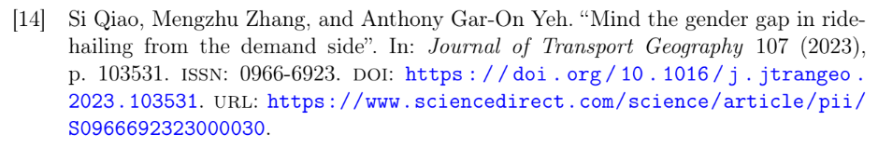
Different formats of journals:
Journal Article:
[1] A. Author, B. Author, "Title of paper," Journal Name, vol. x, no. x, pp. xxx–xxx, Year, DOI.
[1] J. Smith and A. Brown, "Machine learning in education," IEEE Transactions on Education, vol. 65, no. 2, pp. 123–130, 2023.DOI:

Book:
[2] A. Author, Title of Book. City, Country: Publisher, Year.
[2] S. Russell and P. Norvig, Artificial Intelligence: A Modern Approach. New York, USA: Pearson, 2021.

Conference Paper:
[3] A. Author, "Title of paper," in Proc. Conference Name, City, Country, Year, pp. Xxx–xxx.
[3] M. Lee, "AI in smart classrooms," in Proc. IEEE Int. Conf. on Education Technology, London, UK, 2022, pp. 45–50.

Website:
[4] Author (if available), "Title of page," Website Name. [Online]. Available: URL. [Accessed: Month Day, Year].
[4] IEEE, "IEEE citation guidelines." [Online]. Available: https://www.ieee.org. [Accessed: Apr. 10, 2026].

Thesis / Dissertation:
[5] A. Author, "Title," Degree, University, City, Country, Year.
[5] K. Zhang, "Deep learning for physics simulations," Ph.D. dissertation, MIT, Cambridge, MA, USA, 2022.

